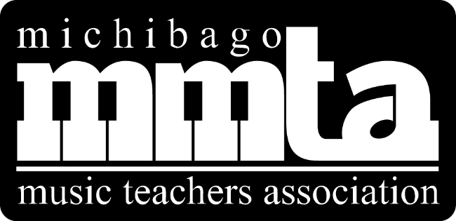

2018-2019
Parent Guide

Visit our home on the web for updates and information
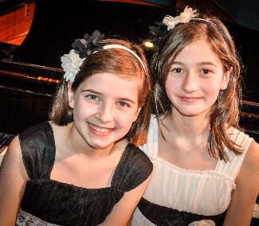
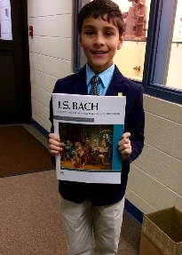
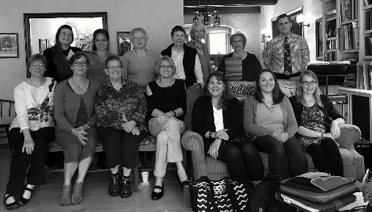
www.MMTAWisconsin.org
Follow us on Facebook!
www.facebook.com/MichibagoMusicTeachersAssociatio
MMTA Events
Master Classes
Each year we invite distinguished guest artists, composers, and teachers to give master classes with opportunities for our students to gain valuable critique.
Fall Festival
This competition by grade level divisions has a different theme each year, such as Baroque, Contemporary, Spanish, Sonatina, etc. and students prepare music based on the theme. Winners from each division participate in a winner’s recital at the end of the day. All students receive a certificate for participation and winners receive a gold sticker on their certificate.
Spring Festival
This competition by grade level divisions alternates between a Composition Festival and a Classical Improvisation Festival.
District Auditions and Badger State Competition
Students prepare various repertoire, test their theory skills with a musicianship exam, and earn points toward awards as they progress each year. Students in state track have the opportunity to advance onto the state competition.
Young Musical Stars Concert
Top students are selected by their teachers to perform at the beautiful Stefanie H. Weill Center in Sheboygan for this exciting series of concerts.

Awards
Michibago supports students of our member teachers by offering awards to further their musical growth. The awards are funded through generous donations as well as through programs sponsored by our organization. Students are invited to apply! Talk to your teacher or see our website for a complete list and description of awards.

Music Study Award
John Michael Kohler Arts Center Senior Honor Recital
Summer Music Camp Award
Travel Grants
Festival Fee Award
Accompanying Award
Event Locations

Lakeland University
W3718 South Dr, Plymouth, WI 53073

Stefanie H. Weill Center
826 N 8th St, Sheboygan, WI 53081

Silver Lake College
2406 S Alverno Rd, Manitowoc, WI 54220

UW River Falls
410 S 3rd St, River Falls, WI 54022

UW Whitewater
410 S 3rd St, River Falls, WI 54022

UW Oshkosh
800 Algoma Blvd, Oshkosh, WI 54901

John Michael Kohler Arts Center
608 New York Ave, Sheboygan, WI 53081

2018/2019 MMTA Event Calendar

October
Saturday, Oct. 20 20th/21st Century Music Festival Deadline
Tuesday, Oct. 30 SLC Piano Days Deadline

November
Saturday, Nov. 3 Piano Days
Silver Lake College
Saturday, Nov. 17 20th/21st Century Music Festival
Lakeland College

January
Friday, Jan. 18 JMKAC Senior Honors Recital Deadline

February
Saturday, Feb. 2 District Auditions Deadline

March
Saturday, March 2 District Auditions
Lakeland University
Friday, March 8 Young Musical Stars Deadline

April
Saturday, April 13 Composition Festival Deadline
Saturday, April 27 Composition Festival

May
Saturday, May 4 10th Annual Young Musical Stars Concert
Stefanie H. Weill Center
Sunday, May 5 JMKAC Senior Honors Recital
John Michael Kohler Arts Center
Saturday, May 11 Badger Competition Northwest
UW River Falls
Badger Competition South & Non-Keyboard
UW Whitewater
Sunday, May 19 Badger Competition Northeast
UW Oshkosh

Events subject to change.
Get the most up to date info from your music teacher or at www.MMTAWisconsin.org.

